Tree Drawing

Questions to ask your client after the drawing ia completed

- Can you tell me about this tree?
- Where does this tree live? Yard? Park? City? Forest?
- What type of tree is this?
- Are there other trees around it?
  - Are those similar or different types of trees?
- What season is it in this picture?
- Who takes care of this tree?
- Is this tree healthy or sick?
- Does this tree provide/give anything?
  - What?
  - To Whom?
- Does this tree need/require anything?
  - What?
  - From Whom?
- If you were standing next to this tree, how tall would you be?
- Is this a real tree or a made up tree?
  - Real tree
    - Where have you seen this tree?
    - Do you have any memories related to this tree?

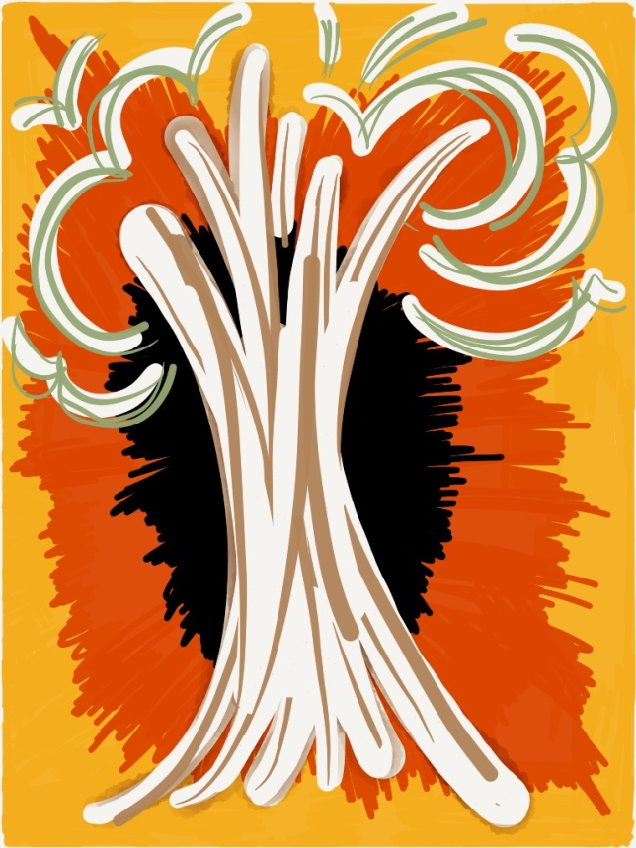
Pamela Hayes, Art Therapist
HayesArtTherapy.com
Facebook: HayesArtTherapy
@ HayesArtTherapy
Instagram: SomethingsSketchy

